**HARDDISK**

**Different type of HDD:**      Mainly five types of HDD available in market.  
1.    **IDE** : Integrated Drive Electronics. IDE drives are also known as PATA drives( Parallel advance technology attachment )  
2.    **SATA** : Serial advance technology attachment   
3.    **SCSI** : Small Computer System Interface. SCSI is pronounced as scuzzy.  
4.    **SAS** : Serial Attached SCSI  
5.    External removable Hard Disk Drive   
  
**IDE / PATA (Integrated Drive Electronics Drive / Parallel Advance Technology Attachment Drive)**  
•    IDE/PATA Drives have usually 40 pins.  
•    IDE/PATA Drives offer 133 MB/sec transfer rate.  
•    It sends 8 bit data at a time.   
•    PATA Cables are used to connect PATA HDD. Two drives can be connected in a single pata cable. One as master and other as slave. The configuration of master and slave is done by different combination of jumpers in the hdd.

**[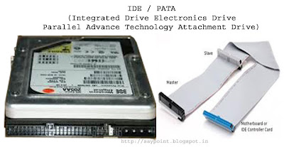](http://4.bp.blogspot.com/-aPmCZ5ITZZc/T8WaVTr2IhI/AAAAAAAAB64/NqnBx51hLOM/s1600/IDE-PATA-HDD.jpg)**

**SATA (Serial Advance Technology Attachment Drive)**  
•    SATA Drives have usually 7 pins, 4 pins in pair of two for sending and receiving data and rest 3 pins are grounded.   
•    SATA Drives offers generally 300MB/sec transfer rate.  
•    It sends data bit by bit.  
•    SATA Cables are used to connect SATA HDD. Only one drive can be connected in a single sata cable.

**[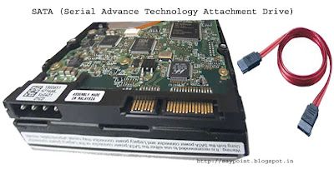](http://1.bp.blogspot.com/-h-wkpuAlnPg/T8WbZzwToxI/AAAAAAAAB7A/FwBXLO780QE/s1600/SATA-HDD.jpg)**

**SCSI (Small Computer System Interface Drive)**  
•    SCSI Drives have usually 50 to 68 pins.  
•    SCSI Drive offers generally 640MB/sec transfer rate.  
•    This drives are hot swappable (means it can be attached or detached from system in running condition)    
•    SCSI cables are used to connect SCSI HDD. Maximum of 16 drives can be connected in a single scsi cable. Each hdd have a 8 bytes hexadecimal code known as WWN (world wide name) for its identification in the cable.

**[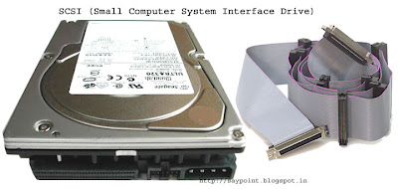](http://4.bp.blogspot.com/-MYiGOKvIqSg/T8WblRpT5EI/AAAAAAAAB7I/IDLxdC3vB3A/s1600/SCSI-HDD.jpg)**

**SAS(Serial Attached SCSI Drive)**  
•    SAS Drives generally offers 805 MB/sec transfer rate.   
•    This drives are hot swappable.   
•    SAS Cables are used to connect SAS Drives. Maximum of 128 drives can be connected in a single sas cable.

**[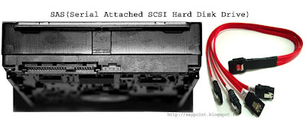](http://1.bp.blogspot.com/-alcjPLwUipc/T8Wbr4h-iPI/AAAAAAAAB7Q/-wTnpZ_FYyE/s1600/SAS-HDD.jpg)**

**External removable HDD**  
This is the hard disk drives external to system typically connect via USB cable. It is removable in nature and features large storage options and portable design.   
**It can be use for :**  
•    Backup  
•    Data storage  
•    External boot disk for system  
•    Data cloning/recovery

**[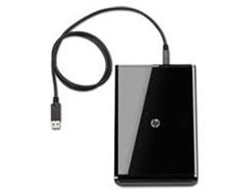](http://2.bp.blogspot.com/-lQQy864vi7k/T8WbyiKdurI/AAAAAAAAB7Y/_A4MamU1ixs/s1600/External+Reovable+Hard+Disk.jpg)**

WD Caviar Blue 500 GB Desktop Internal Hard Drive

RS.3190

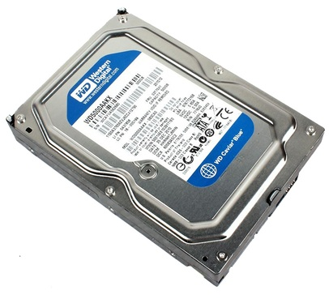

WD Caviar Green 1 TB Desktop Internal Hard Drive

RS.4299

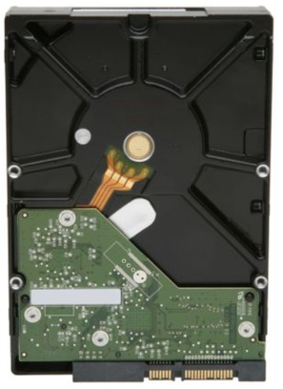

WD Blue WD10EZEX 1 TB Internal Hard Drive

RS.4199

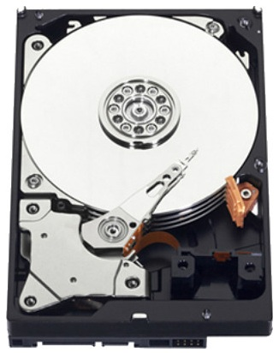

Samsung 840 EVO 120 GB Desktop & Laptop Internal Hard Drive

RS.6340

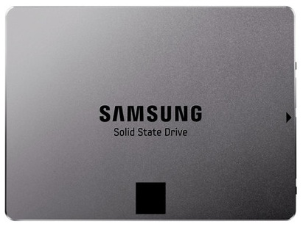

Corsair Force Series GS 128 GB SSD Internal Hard Drive

RS.7175

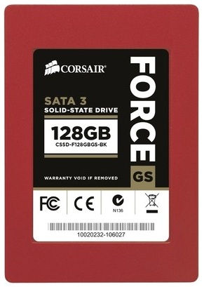

# Seagate Barracuda SV-35 2 TB Desktop Internal Hard Drive

**Rs. 6100**

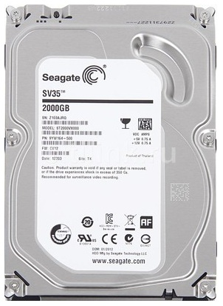

# ADATA Premier Pro 256 GB SSD Internal Hard Drive

**Rs. 9999**

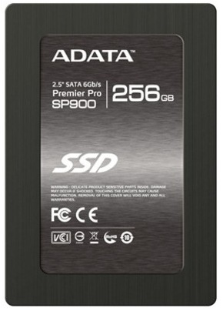

Kingston SV300S37A/60G Internal Hard Drive

RS.4100

